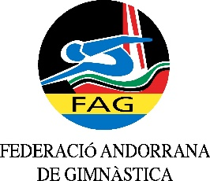
International Tournament
Prejunior, Junior & Senior
March 2020

This Form is to be sent in WORD Format (no scans) to:
Host Federation
ANDORRAN GYMNASTICS FEDERATION
Federació Andorrana de Gimnàstica
Centre de Tecnificació Esportiva
c/ Narciso Yepes s/n AD300 - Ordino
Ms. Anna Pallarés
Phone: (+376) 343 668
E-mail: andgymcup@gmail.com

VISA REQUEST Form

Federation/club |  | Contact person:
 |  | Phone:
 |  | E-mail:

LAST NAME,  First name | Function | Gender  M/F | Date of birth  dd.mm.yyyy | Citizenship and  passport N° | Passport expiry date | Arrival date | Departure date | City*
* city where the visa application support letter must be sent to
Special requirements

Place and date | Seal of the NF/club | Signature

