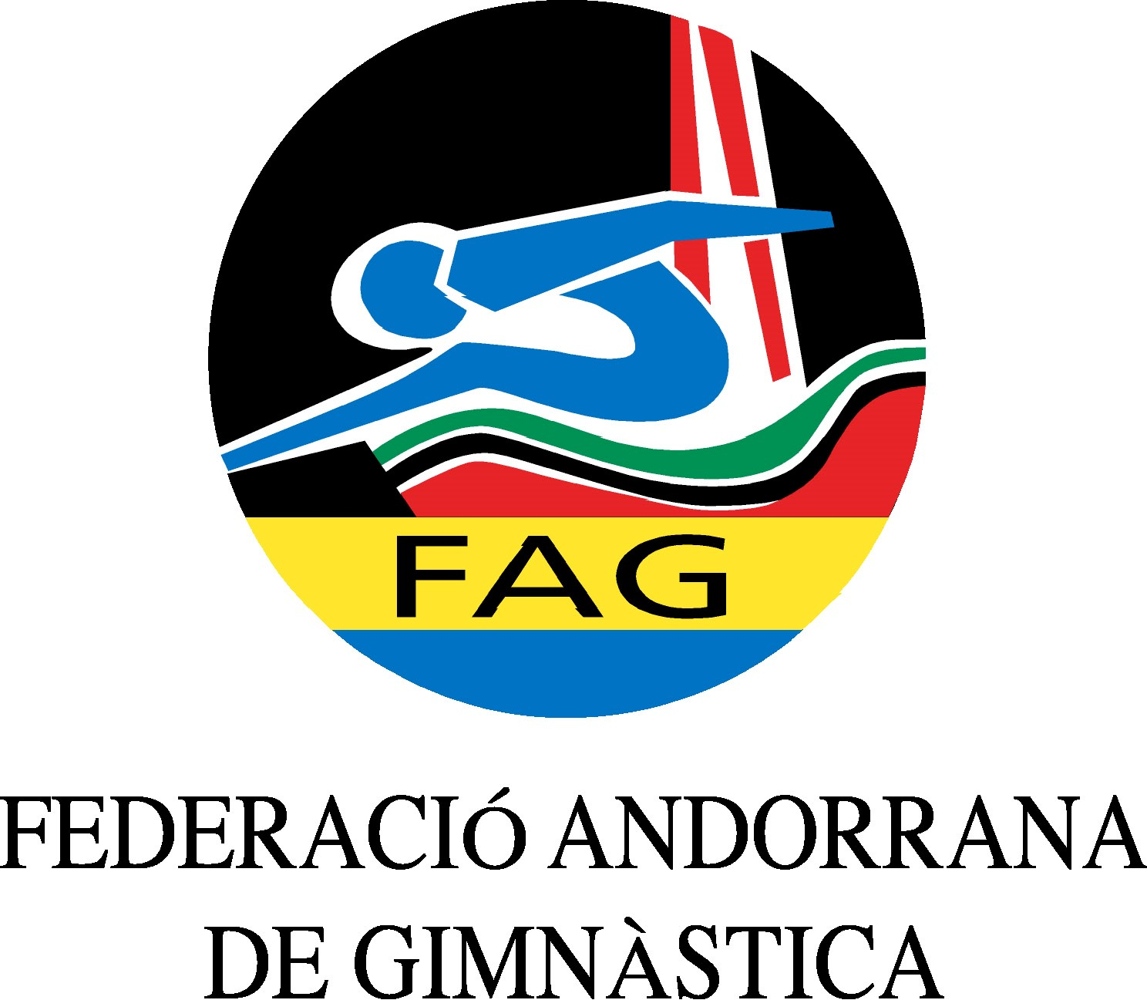
International Tournament
Prejunior, Junior & Senior
March 2020

Form to be sent to:
Organizing Committee / Host Federation
ANDORRAN GYMNASTICS FEDERATION
Federació Andorrana de Gimnàstica
Centre de Tecnificació Esportiva
c/ Narciso Yepes s/n AD300 - Ordino
Ms. Anna Pallarés
Phone: (+376) 343 668
E-mail: andgymcup@gmail.com

Deadline: 13.02.2020
definitive registration

Federation/club |  | Contact person:
 |  | Phone:
 |  | E-mail:

Category | Number of people
Prejunior gymnasts
Junior gymnasts
Senior gymnasts
Coaches
Judge

Extra persons:

Place and date | Seal of the NF/club | Signature

