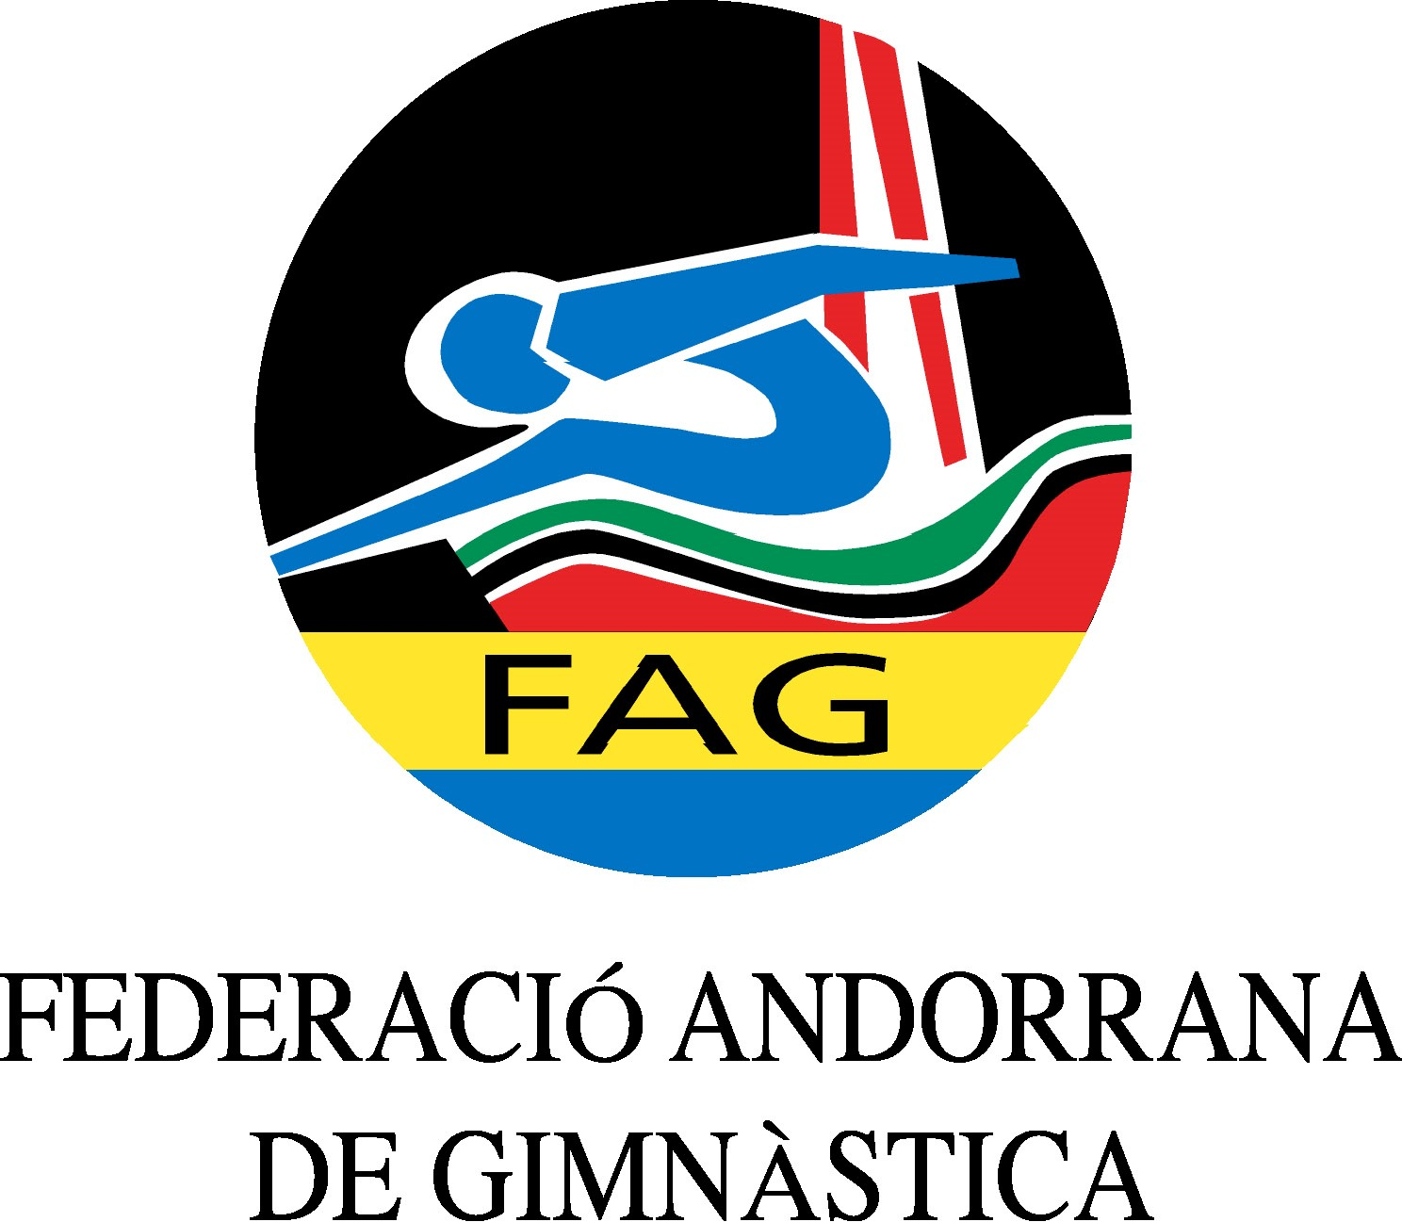
International Tournament
Prejunior, Junior & Senior
March 2020

Form to be sent to:
Organizing Committee / Host Federation
ANDORRAN GYMNASTICS FEDERATION
Federació Andorrana de Gimnàstica
Centre de Tecnificació Esportiva
c/ Narciso Yepes s/n AD300 - Ordino
Ms. Anna Pallarés
Phone: (+376) 343 668
E-mail: andgymcup@gmail.com

Deadline: 01.03.2020
nominative registration

Federation/club |  | Contact person:
 |  | Phone:
 |  | E-mail:

Name | Category (prejunior/junior/senior) | Date of Birth | Apparatus
Gymnast
Gymnast
Gymnast
Gymnast
Gymnast
Gymnast
Gymnast
Gymnast
Coach:
Coach:

Judge:
Extra persons:

Place and date | Seal of the NF/club | Signature

