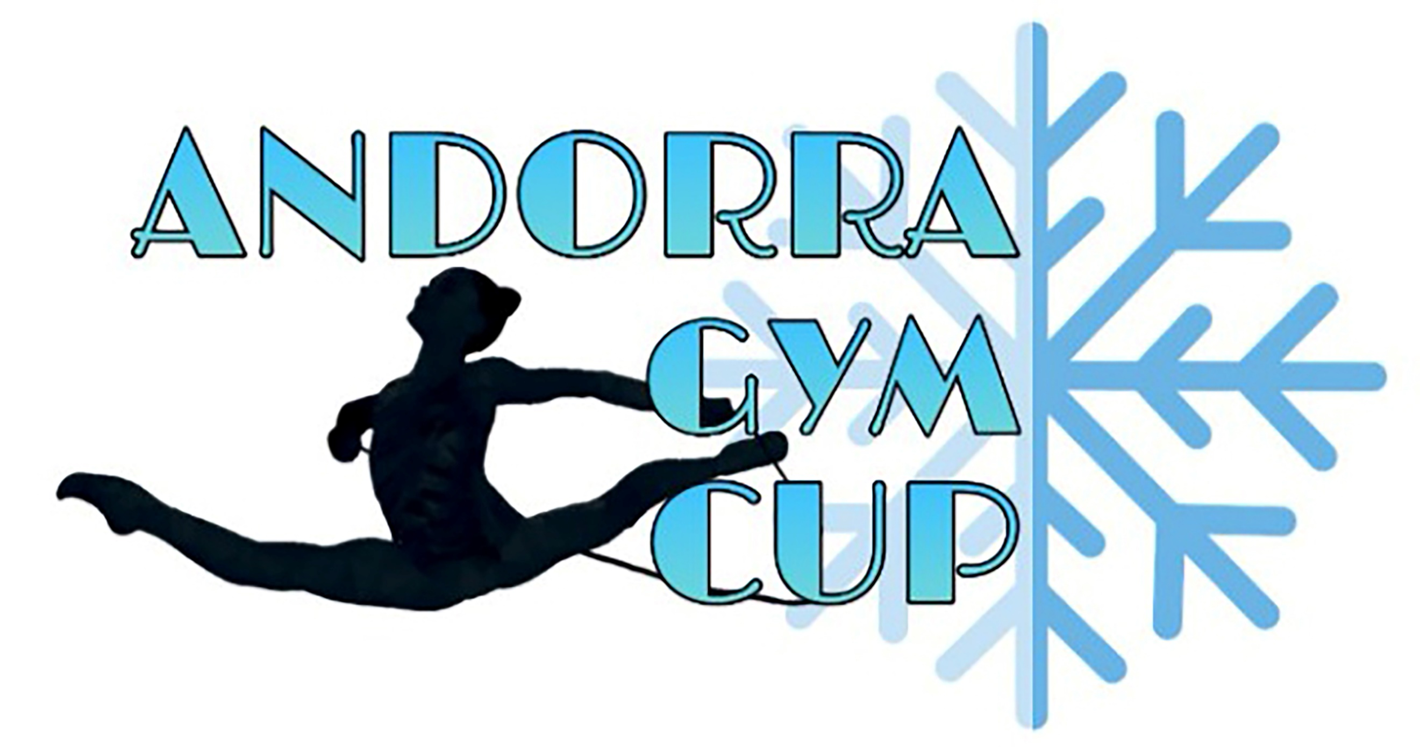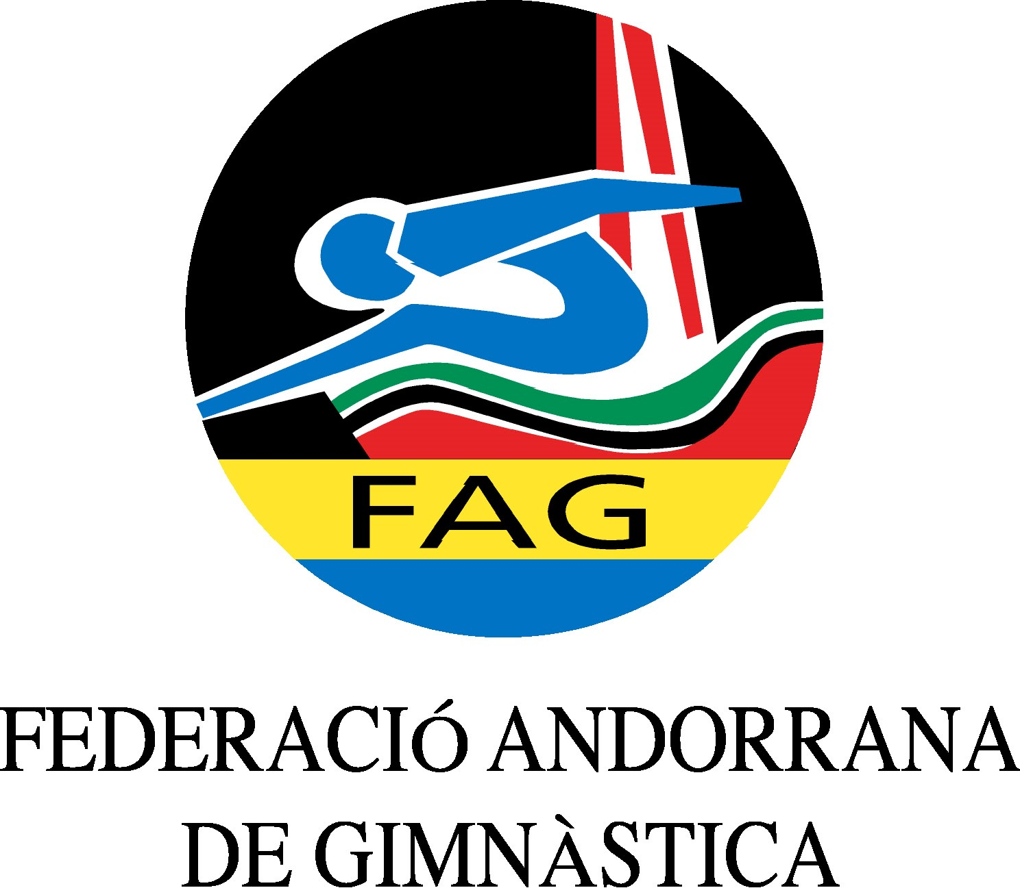
International Tournament
Prejunior, Junior & Senior
March 2020

Form to be sent to:
Host Federation
ANDORRAN GYMNASTICS FEDERATION
Federació Andorrana de Gimnàstica
Centre de Tecnificació Esportiva
c/ Narciso Yepes s/n AD300 - Ordino
Ms. Anna Pallarés
Phone: (+376) 343 668
E-mail: andgymcup@gmail.com

Deadline: 01.03.2020
ACCOMMODATION Form

Club/Federation |  | Contact Person:
 |  | Phone:
 |  | E-mail:

Room type  (i.e. single/double/triple/quadruple) | Arr. day | Dept. day | LAST NAME,  First Name | # of rooms | # of nights | Price per person/night |  | Total
Single |  |  |  |  |  | 132€
Double |  |  |  |  |  | 98€
Triple |  |  |  |  |  | 98€
Quadruple |  |  |  |  |  | 98€
 |  |  |  |  | Grand Total

Special requirements

Place and date | Seal of the club/federation | Signature

